Resource availability and disturbance shape maximum tree height across the Amazon

*Tall trees are key drivers of ecosystem process in tropical forest, but what controls the distribution of the very tallest trees remain poorly understood. The recent discovery of grove of trees over 80 meters tall in the Amazon rainforest requires a reevaluation of current thinking. We used high-resolution airborne laser surveys to measure canopy height across 282,750 ha of primary old-growth and secondary forests sampling the entire Brazilian Amazon. We first investigated the how resources and disturbances shape the maximum height distribution across the Brazilian Amazon, and secondly the relationship between the occurrence of giant trees located using this unique dataset and the environmental factors that influence tree demography and thereby control height. We concluded that drivers of height development are fundamentally different from those influencing the occurrence of giant trees. Thus changes in wind and light availability shape their distribution as much as precipitation and temperature, altogether shaping the demographics and composition of forested biomes. The location of giant trees should be carefully considered by policy-makers when identifying important hotspots for the conservation of biodiversity in the Amazon.*

# Introduction

The Amazon is the largest rain forest on Earth, covering 5.5 million square kilometers, and storing about 17% of all vegetation carbon. Ecologists have long taken an interest in comparing the rain forests structure across the tropics (Yang et al., 2016), and have reached a consensus that the Amazon supports shorter trees, and therefore stores a lower amount of carbon per hectare, than the forests of tropical Africa and Asia (Cao & Woodward, 1998; Feldpausch et al., 2012). Previous studies have showed some potentially height regions in the Amazon Forest and debated the factors which govern Amazon tree growth (Lefsky 2010; Simard et al., 2011; Larjavaara, 2013; Tao et al., 2016). However, the recent discovery of giant trees - up to 88 m tall - in the Amazon basin (Gorgens et al., 2019) challenges some paradigms and poses new questions about the drivers causing the spatial distribution of tall trees in the Amazon, and consequently about how maximum height is shaped across amazonian sites.

The environment is a complex interaction that provides the organism with its heat, light, water, elements, and compounds (Billings, 1952). Tree height is fundamentally linked to growth, survival, and reproduction strategies, and is ultimately related to the ability to pre-empt light resources and disperse diaspores (Díaz et al., 2016). Height growth is partly governed by local scale factors such as water availability, temperature, rooting depth, and soil type (Anderegg et al., 2016; McDowell & Allen, 2015; Coomes et al., 2006; Niklas, 2007), with precipitation and potential evapotranspiration consistently reported as key factors determining plant height across biomes (Moles et al., 2009; Larjavaara, 2013; Rueda et al., 2016).

While resource availability (e.g. sunlight, nutrients, CO2, and water) controls a tree’s ability to produce biomass through photosynthesis, natural disturbances (e.g. windthrow, drought, or lightning) and history of anthropogenic actions (e.g. selective logging, forest fragmentation) increase the likelihood of mortality and limit the time available to trees to grow taller (Bennett et al., 2015; Powers et al., 2020; Yanoviak et al., 2019; Almeida et al., 2019). Tall trees are likely to have developed strategies for surviving diseases and pathogens  (van Gelder et al., 2006; Aleixo et al., 2019) as well as climatic fluctuations (Sakschewski et al., 2016) and resisting wind damage (Jagels et al., 2018).

To reach such immense sizes, trees must fulfill at least three conditions:  they must (1) have an evolutionary design that is capable of transporting water to great heights and overcome highly negative water potentials to deliver that water toward tissues in the upper canopy (Koch et al., 2004; Niklas, 2007; McDowell et al., 2008);  (2) inhabit an area with optimal environmental conditions (such as climate, soil properties, and water) that meet species-specific requirements (Simard et al., 2018; Scheffer et al., 2018) and (3) grow in regions with a low frequency of natural or anthropogenic disturbance events (Larjavaara, 2013; Lindenmayer & Laurance, 2016; Scheffer et al., 2018; Enquist et al., 2020).

The sheer size of the Amazon, its environmental heterogeneity and species diversity, pose challenges and practical difficulties to understand general ecological relationships and biogeographical patterns (Tuomisto et al., 2019). Forest plots provide many valuable insights to investigate the influences of the environment on tree height but they can only represent a minuscule fraction of the total forest area (Chave et al., 2020). Currently, a network of 5,351 forest inventory plots established across the Brazilian Amazon, of known and published sites recently compiled by (Tejada et al., 2019), represents only 0.0013% of the total forest area in this region. In addition, the plot distribution is spatially clustered in close proximity to major roads or large rivers (Stropp et al., 2020), implying a spatial distribution bias (Marvin et al., 2014) since about 42% of the total Brazilian Amazon lies over 50 km from the nearest forest inventory plots (Tejada et al., 2019). Remote sensing can remove sampling biases and uncertainty about ecological patterns (Schimel et al., 2015) and provides large datasets with which to uncover the environment controls of forest structure (Asner et al., 2010). In particular airborne LiDAR  (Light Detection and Ranging) generates valuable high-resolution 3D information of forest canopy structure (Görgens et al., 2016; Coomes et al., 2017), and can be used as an intermediary to integrate field data with satellite sources (Asner, 2009; Bae et al., 2019).

The question of how resources and disturbances determine maximum height across the Amazon has not been fully explored. Besides, forest giant trees are disproportionately vulnerable to disturbances and thus their conservation requires particular attention (Pennisi, 2019; Yanoviak et al., 2019; Stovall et al., 2019; Enquist et al., 2020). In this study, we employed the largest airborne laser data collection in the Amazon to contribute to the understanding of (1) how resources and disturbances shape the maximum height distribution across the Brazilian Amazon, and (2) what drives the occurrence of giant trees (taller than 70 meters). We conducted an extensive analysis relating remotely sensed environmental variables to the maximum height recorded in the transects.

# Methods

Between 2016 and 2018, an airborne mission (held by National Institute for Space Research - INPE and funded by Amazon Fund) collected airborne LiDAR data from 906 transects of 375 ha (12.5 x 0.3 km) each, randomly spread across primary and secondary forests defined by the PRODES database - layer mask of primary old-growth forests (**PRODES, INPE**, 2016) and by the TerraClass database - a layer mask of secondary forest (**TerraClass, INPE**, 2014). Details about LiDAR parameterization, processing, and the EBA project characteristics can be consulted in (Gorgens et al., 2019). Briefly, the average pulse density was set at 4 pulses m−2, the field of view equal to 30°, and flying altitude of 600 m. The pulse footprint was set to be below 30 cm, based on a divergence angle between 0.1 and 0.3 mrad. Each transect was processed by identifying the returns backscattered from the ground and interpolating a 1m spatial resolution digital terrain model (DTM) from them. Then, the DTM was employed to calculate the heights above ground from the returns backscattered from the vegetation (Görgens et al., 2016). The uppermost vegetation heights were then employed to compute a canopy height model CHM at the same spatial resolution as the DTM.

The terrain could also influence the extraction of the individual tree height. As the height is computed based on the diference between surface elevation and terrain elevation, difficulties in the true terrain determination could influence the height retrieval. Studies reported an underestimation of the tree height in hilly terrains, but in a similar way that other measurement approaches (e.g. field measurements). Results showed the LiDAR surveys with at least 4 points per square meters have high penetration into the canopy to height estimation (Clark et al., 2004; Glenn et al., 2011; Andrade et al., 2018).

A forest consists of superimposed groups that occur in different combinations over the landscape, and each unit is sensitive to certain special aspects of the environment (Vanclay, 1992). The soil (fertility, drainage), climate (temperature and rainfall patterns), topography (altitude, aspect), and other factors can only give a general indication of site productivity because they fail to account for any local variations in the site (e.g. the species present) (Binkley et al., 2004). Site comparison, like we are proposing here, should prefer indicators not unduly influenced by stand condition, use history, or diversity complexity. Maximum stand height for sites that are sufficiently large to reflect the maximum height that the nominated species is likely to attain is a perfect indicator (Daubenmire, 1976). Using an individual tree approach the emergent individual was located using a local minimum filter and the tree height determined. A single tallest tree was identified, isolated and located per transect. All the trees were manually inspected to exclude non-trees maximum derived from artifacts, ensuring that all the largest heights indeed depicted a tall tree (Supplementary Figure 1). The height distribution of the tallest individual trees select for further analysis is present in Fig. 1.

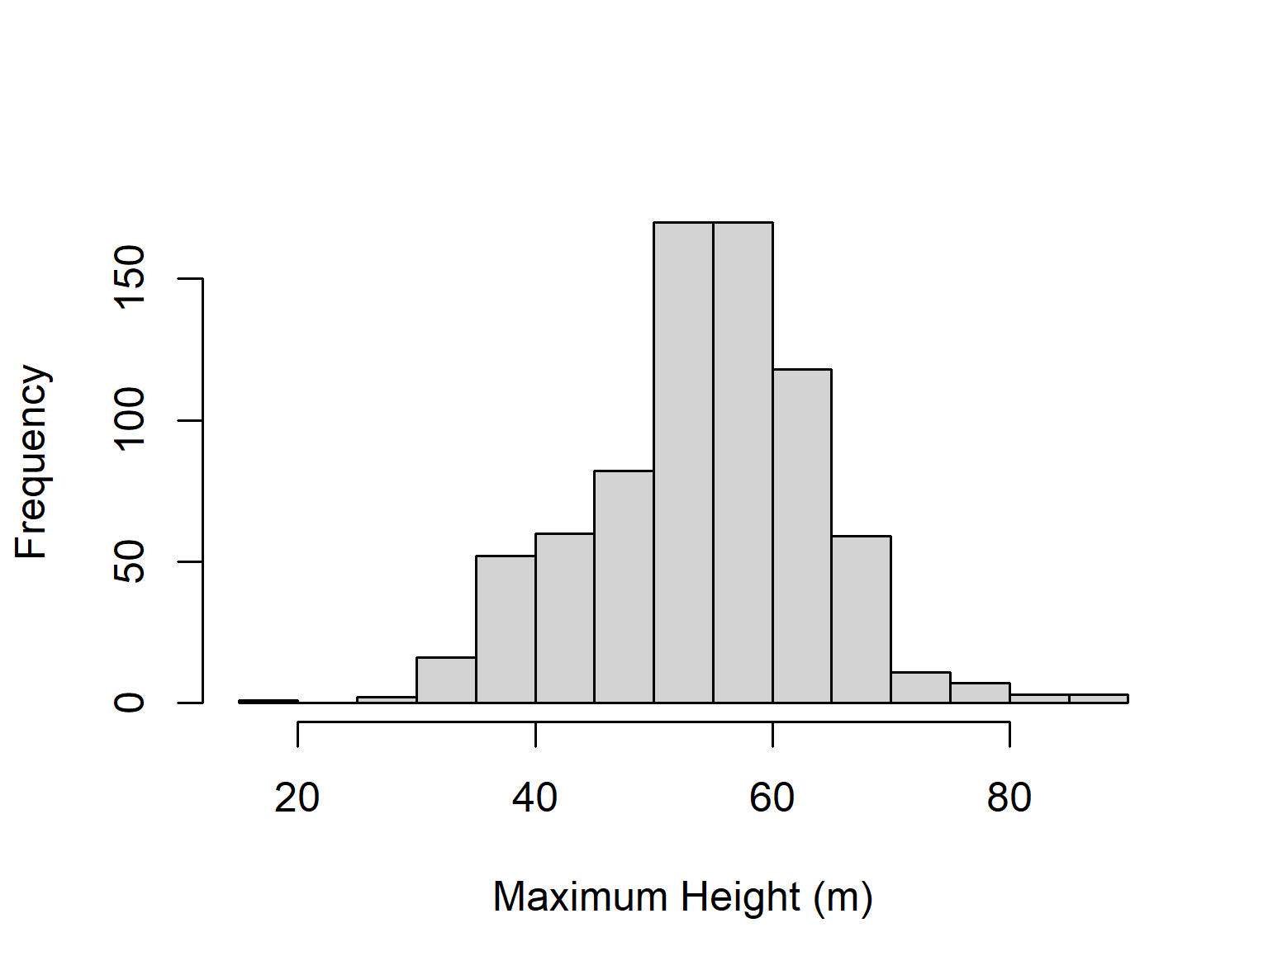

*Figure 1. Maximum tree height distribution of the 906 trees extracted from the 906 airborne laser scanned transects dispersed across the Brazilian Amazon.*

## Environmental variables

To investigate drivers influencing the spatial distribution of giant trees, we initially considered a total of 18 environmental variables: (1) fraction of absorbed photosynthetically active radiation (FAPAR; in %); (2) elevation above sea level (Elevation; in m);  (3) the component of the horizontal wind towards east, i.e. zonal velocity (u-speed ; in m s-1); (4) the component of the horizontal wind towards north, i.e. meridional velocity (v-speed ; in m s-1); (5) the number of days not affected by cloud cover (clear days; in days yr-1); (6) the number of days with precipitation above 20 mm (days > 20mm; in days yr-1 ); (7) the number of months with precipitation below 100 mm (months < 100mm; in months yr-1 ) ; (8) lightning frequency (flashes rate); (9) annual precipitation (in mm); (10) potential evapotranspiration (in mm); (11) coefficient of variation of precipitation (precipitation seasonality; in %); (12) amount of precipitation on the wettest month (precip. wettest; in mm); (13) amount of precipitation on the driest month (precip. driest; in mm); (14) mean annual temperature (in °C); (15)  standard deviation of temperature (temp. seasonality; in °C); (16) annual maximum temperature (in °C); (17) soil clay content (in %); and (18) soil water content (in %).

The FAPAR was derived from land surface reflectance product calibrated and corrected from the National Oceanic and Atmospheric Administration’s (NOAA) Advanced Very High-Resolution Radiometer (AVHRR), which is a consistent time-series dataset spanning from the mid-1980s to present and suitable for climate studies (Tao et al., 2016). FAPAR is a primary vegetation variable controlling the photosynthetic activity of plants and is considered an essential climate variable (Mason et al., 2010).

The elevation was computed based on the third version of the Shuttle Radar Topography Mission (SRTM) provided by the National Aeronautics and Space Administration Jet Propulsion Lab (NASA JPL) (Farr et al., 2007; Liu et al., 2014). The SRTM mission collected data during ten days of operations, using two synthetic aperture radars: NASA’s C band system (5.6 cm wavelength) and an X band system by DLR (3.1 cm). C-band partially penetrates the vegetation canopy, with depth varying with vegetation structure. Since Amazonian vegetation is dense throughout, for the purposes of this study the C-band DEM is assumed to vary consistently with topography across the region.

We used the maximum daily mean wind speeds over the last 5 years from the fifth major global reanalysis (ERA5) produced by the European Centre for Medium-Range Weather Forecasts (ECMWF). The reanalysis combined model data with observations from across the world into a globally complete and consistent dataset (Olauson, 2018). Two wind velocities were considered: u-speed which is the zonal velocity (i.e. the component of the horizontal wind towards east), and v-speed which is the meridional velocity (i.e. the component of the horizontal wind towards north). These products are used extensively for modeling wind power both in academia and industry (Olauson, 2018; Albergel et al., 2019; Ramon et al., 2019).

The number of clear days was computed based on Moderate Resolution Imaging Spectroradiometer (MODIS) surface reflectance products. MODIS products provide an estimate of the surface spectral reflectance as it would be measured at ground level in the absence of atmospheric scattering or absorption (Kang et al., 2005; Bisht & Bras, 2010). We used the Terra MOD09GA Version 6 product, which provides an estimate of the surface spectral reflectance of MODIS, corrected for atmospheric conditions such as gases, aerosols, and Rayleigh scattering.

Temperature and precipitation were obtained from the WorldClim database of bioclimatic variables, which are derived from weather station data compiled for the 1950-2000 period (Hijmans et al., 2005; Fick & Hijmans, 2017). The main source of data was the Global Historical Climatology Network (GHCN), complemented with other global, national, regional, and local data sources, which were added if they were further than 5 km away from stations already included in the GHCN.

The lightning frequency was provided by Lightning Imaging Sensor (LIS) instrument onboard the Tropical Rainfall Measuring Mission provided by NASA Earth Observing System Data and Information System (EOSDIS) Global Hydrology Resource Center. The LIS provided the basis for the development of a comprehensive global thunderstorm and lightning climatology to detect the distribution and variability of total lightning occurring in the Earth (Albrecht et al., 2016).

The potential evapotranspiration was provided by the TerraClimate dataset, a global monthly climate and water balance for terrestrial surfaces spanning 1958–2015. The layer combined high-spatial-resolution climatological normals from WorldClim with Climate Research Unit (CRU) Ts4.0 and the Japanese 55-year Reanalysis (JRA-55) data. The Reference Evapotranspiration was calculated using the Penman-Monteith approach (Abatzoglou et al., 2018).

The number of months per year with precipitation below 100 mm and the number of days per year with precipitation above 20 mm was computed based on the Climate Hazards Group InfraRed Precipitation with Station data (CHIRPS) dataset. CHIRPS incorporated 0.05° resolution satellite imagery with in-situ station data to create gridded rainfall time series for trend analysis and seasonal drought monitoring (Funk et al., 2015).

Edaphic variables were obtained from The OpenLandMap produced by the OpenGeoHub Foundation and contributing organizations. The clay content (fine particles < 2 μm) and water content layers, both with a spatial resolution of 250 m, were created based on machine learning predictions from a global compilation of soil profiles and samples (Arsanjani et al., 2014).

To help visualization of the regional-level, we used the division of the Brazilian Amazon into eight regions, according to the classification of (Morrone, 2014). This regionalization is based on biogeographic analyses of terrestrial plant and animal taxa of the Neotropical region and seeks to provide universality, objectivity, and stability, such that it can be applied when describing distributional areas of particular taxa or comparing different biogeographic analyses.

## Random Forest and Maximum Entropy

To explore the influence and importance of the environmental variables for development in tree height, we employed Random Forest modeling, which consists on generating a large number of regression trees, each constructed considering a random data subset. The regression trees are used to identify the best sequence for split the solution space to estimate the output. To visualize how the environmental variables relate to the maximum height we used marginal plots, estimating the maximum height by one variable per time, keeping others constant at average. Among the initial 18 environmental variables, two of them (precipitation on driest month and months < 100mm) were excluded due to high correlation (> 0.80) to other independent variables. Using the coordinates of the tallest tree within each lidar transect, we performed a simple extraction of the values from the variable layers. Tree height was then modeled against the factors using a random forest algorithm, which recursively computes classification and regression trees (CART) from random subsets, a k-fold (k = 15) cross-validation method, and 500 as the number of CART. The number of variables randomly sampled as candidates at each split was set to 10. The adjusted model was evaluated considering the mean absolute error (MAE), root mean squared error (RMSE), and coefficient of determination (R²) of cross-validated predicted versus observed values. To assess the overall relative variable importance we used the mean decrease in accuracy. For further information about the variables importance, see in Supplementary Figure 2 a plot considering the mean decrease in accuracy and the mean decrease in node impurity for all the variables. The resulting Random Forest model was finally implemented using the environmental variables to deliver a map of estimated heights of tallest trees across the Amazon.

Then we focused on the tallest trees only - those over 70 m in height - to determine the conditions which allow them to occur. We employed a maximum entropy envelope approach (MaxEnt) commonly applied to modelling species geographic distributions with presence-only data and indicate better discrimination of suitable versus unsuitable areas for the species (Phillips et al., 2006). The variable importance of the MaxEnt model was used to indicate the most relevant characteristics sustaining extreme height individuals and the potential location for new occurrence.  The observations higher than 70 m were filtered out and used to adjust an envelope model based on maximum entropy. In its optimization routine, the algorithm tracked how much the model gain was improved when small changes were made to each coefficient value associated with a particular variable.  Each variable was then ranked based on the proportion of all contributions. The resulting MaxEnt model was finally implemented using the environmental variables to deliver a map of probability of occurrence for trees taller than 75 m across the Amazon.

# Results

Trees exceeding 50 m were registered in 540 transects, widely distributed across many parts of the Brazilian Amazon. Within those transects, only 23 showed trees above 70 m and only 6 registered trees above 80 m. From widely distributed, when trees go taller, their distribution become concentrated in the eastern Amazon (contact of Roraima and Guianan Lowlands biogeographic regions, Fig. 2).

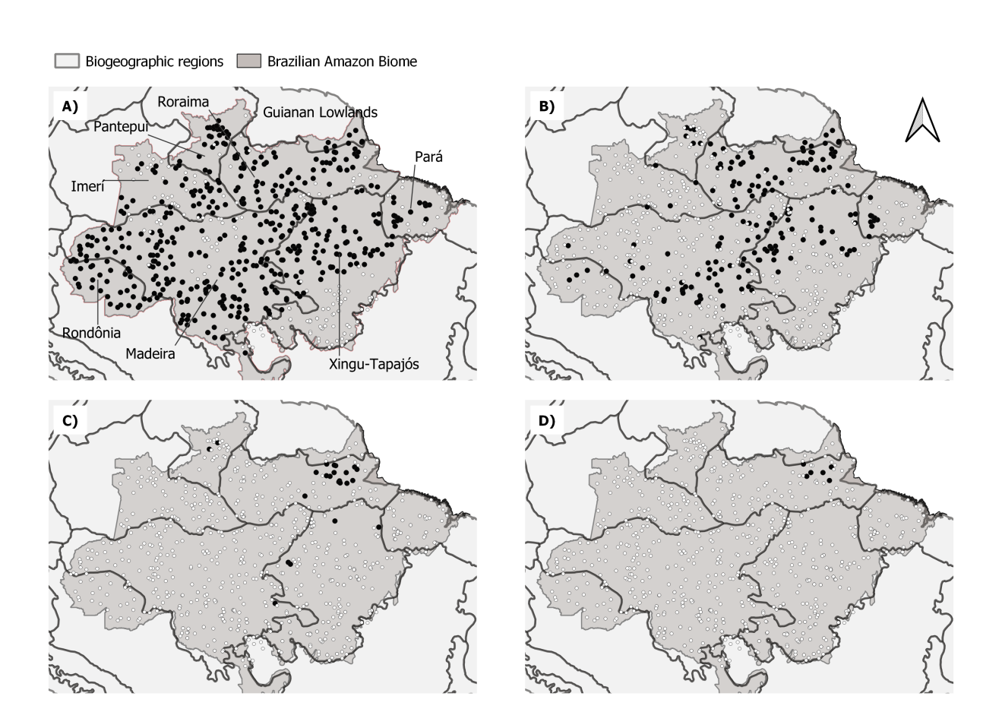

Figure 2. Maps of the Brazilian Amazon showing the location of transects considering height thresholds: 50 m, 60 m, 70 m, and 80 m in height. Black circles indicate transects with trees taller then the threshold, white circles indicate remaining transects.

By the importance variable metrics extract from the Random Forest model, the number of clear days, clay content in the soil, elevation and mean annual precipitation were found to be the strongest drivers of maximum tree height, while soil water content was the weakest predictor. All the other variables could be included in an intermediate group with importance values close to each other, ranging from 21.3 to 15.6 (Table 1 and Supplementary Figure 2). To examine the environmental variables modulating height pattern in the Amazon, we predicted maximum tree height as a function of environmental variables using a Random Forest approach.

Table 1. Variables used to estimate maximum height distribution and evaluate its distribution, ranked by variable importance results in the Random Forest model

|  |  |  |  |  |  |  |  |
| --- | --- | --- | --- | --- | --- | --- | --- |
| Layer | Definition | Related to | Unit | Source | Spatial resolution (Time resolution) | Expected influence in max. height | Importance  (increase accuracy) |
| clearDays | number of clear days per year | energy balance - water balance - radiation | days | MODIS | 500 meters  (2014 - 2018) | Negative | 25.5 |
| clayContent | fraction of clay content | soil structure - physical properties - water availability | % | OpenLandMap | 250 meters | Positive | 23.4 |
| topography | elevation above sea level | distance to water - flooding zones - soil | m | SRTM | 30 meters | Positive | 23.3 |
| pannual | average annual precipitation | precipitation - precipitation intensity - precipitation distribution | mm | WorldClim | 30 arc seconds | Positive | 22.4 |
| pseason | precipitation seasonality | precipitation - precipitation intensity - precipitation distribution | mm | WorldClim | 30 arc seconds | Positive | 21.3 |
| tseason | temperature seasonality | temperature - temperature distribution | C | WorldClim | 30 arc seconds | Negative | 21.3 |
| uspeed | zonal speed (W-E) | storms - convective winds | m/s | ECM-RWF | 0.25 degrees  (2014-2018) | Negative | 21.1 |
| pet | potential evapotranspiration | energy balance - water balance - radiation - vegetation health - anthropic regions - soil exposure | mm | TerraClimate | 2.5 arc minutes  (1990 - 2016) | Positive | 20.2 |
| fapar | fraction of absorbed photosynthetically active radiation | radiation - vegetation health - anthropic regions - soil exposure | % | NOAA AVHRR | 0.05 degrees  (2016 - 2018) | Positive | 20.0 |
| pwettest | precipitation of the wettest month | precipitation - precipitation intensity - precipitation distribution | mm | WorldClim | 30 arc seconds | Negative | 19.9 |
| tmax | maximum temperatura | storms - convective winds | C | WorldClim | 30 arc seconds | Negative | 19.8 |
| vspeed | meridional speed (N-S) | storms - convective winds | m/s | ECM-RWF | 0.25 degrees  (2014-2018) | Negative | 18.1 |
| lightning | lightining rate | storms - convective winds | flashes rate | LIS TRMM | 0.1 degrees  (1998 - 2018) | Negative | 18.0 |
| days20 | days with precipitasion higher then 20 mm | storms - convective winds - precipitation | days | CHIRPS | 0.05 degrees  (2014-2018) | Negative | 16.4 |
| tannual | daily average annual temperature | temperature - temperature distribution | C | WorldClim | 30 arc seconds | Negative | 15.6 |
| waterContent | fraction of water content | soil structure - physical properties - water availability | % | OpenLandMap | 250 meters | Positive | 9.7 |
| month100 | month with precipitation below 100 mm | precipitation - precipitation intensity - precipitation distribution | months | CHIRPS | 0.05 degrees  (2014-2018) | Negative | Removed by high correlation |
| pdriest | precipitation of the driest month | precipitation - precipitation intensity - precipitation distribution | mm | WorldClim | 30 arc seconds | Positive | Removed by high correlation |

The Random Forest model obtained MAE = 3.62 m, RMSE  = 4.92 m, and R² = 0.735. A resulting map of Random Forest model predicted maximum tree height shows that 56,747 km² (1.03% of the Amazon) support trees above 70 meters. Those regions are concentrated in eastern Amazon, with the trees specifically achieving greatest heights in the northeastern part of Roraima, and some isolate records in Pantepui and in the confluence of Madeira and Xingu-Tapajos.  Since low values of FAPAR are related to degraded forests and anthropogenic regions, we performed the same analysis after excluding areas with FAPAR values under 80%, which resulted in the elimination of 133 transects. Similar spatial distributions for maximum tree height persisted similarly after removing these potential anthropogenic effects, demonstrating that the underlying patterns we report are naturally driven by the environmental factors (Fig. 3).

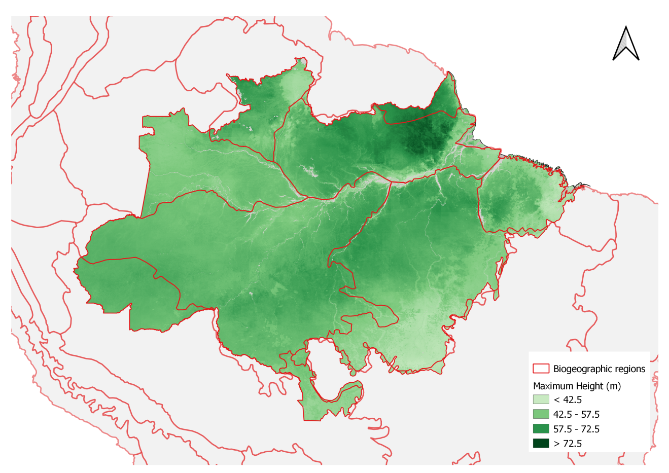

Figure 3. The maximum tree height distribution estimated by the Random Forest model based on the environmental variables. Available at https://doi.org/10.5281/zenodo.4036988.

The number of clear days was the strongest predictor of maximum height (Table 1). The shape of this relationship resembles a step function (Fig. 4), in which regions with the number of clear days below 130 days per year support tall trees, above this level, we observe an abrupt decline in maximum height. Elevation was also a key predictor of tree height, with low-lying forests growing 7 m lower than trees in terrains above 40 m above sea level. An increase in soil clay content from 20% to 40% translated into a 7 m increase in maximum height.  Our results also demonstrate mean annual precipitation as a key factor for trees to grow taller, with a tolerance curve peaking at around 2,300 mm yr-1 as optimal annual precipitation across the Brazilian Amazon. In comparison to these areas, we observe a 4 m decline in maximum tree height in regions with annual precipitation below 1,500 mm yr-1 or above 3,000 mm yr-1. From the intermediate importance variables, we highlight the zonal velocity (u-speed) and FPAR influencing height variation in ranges around 6 m.

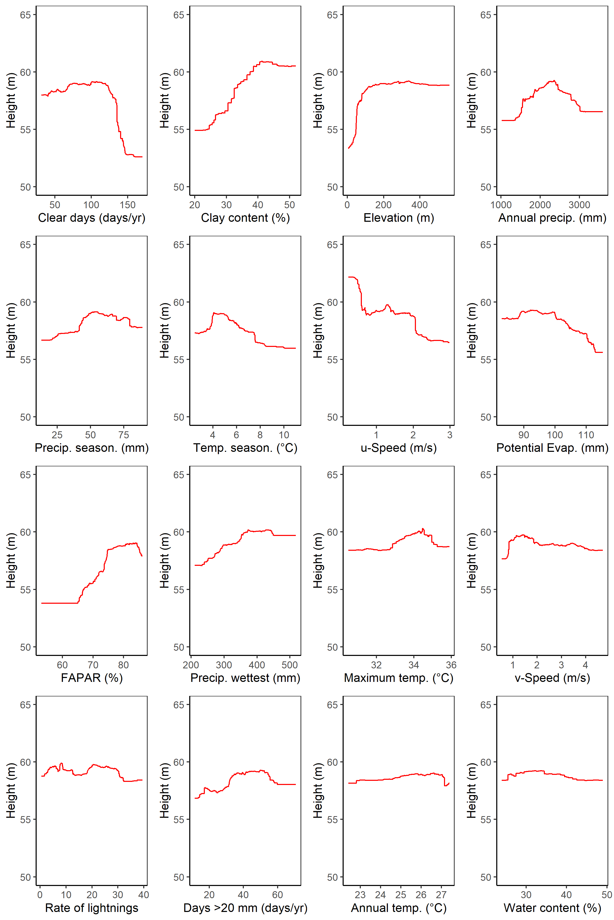

Figure 4. The marginal plot obtained for each environmental variable in the random forest model, keeping others constant on the average. Lines close to horizontal indicate a given environmental factor having little effect on the height of tall trees.

The results of the MaxEnt approach are focusing on the occurrence of trees taller than 70 m in height. The extraordinarily tall trees were found in conditions characterized by a much smaller set of environmental variables from those which drove the large-scale patterns of maximum height. The maximum entropy model shows that the niche is dominated mostly by wind speed (relative importance of 67.7 %). The second most important driver of tall tree occurrence was the elevation above sea level (relative importance of 12.3 %). It is worthwhile noting that relative importance values reflect the proportion of all contributions to explain the presence of the tallest trees (Fig. 5). The resulting map of predicted occurrence of the tallest trees in the Amazon from the MaxEnt model shows that the probability of maximum tree height occurrence is highest in northeastern Amazon (Fig. 6), more specifically in the Roraima and Guianan Lowlands.

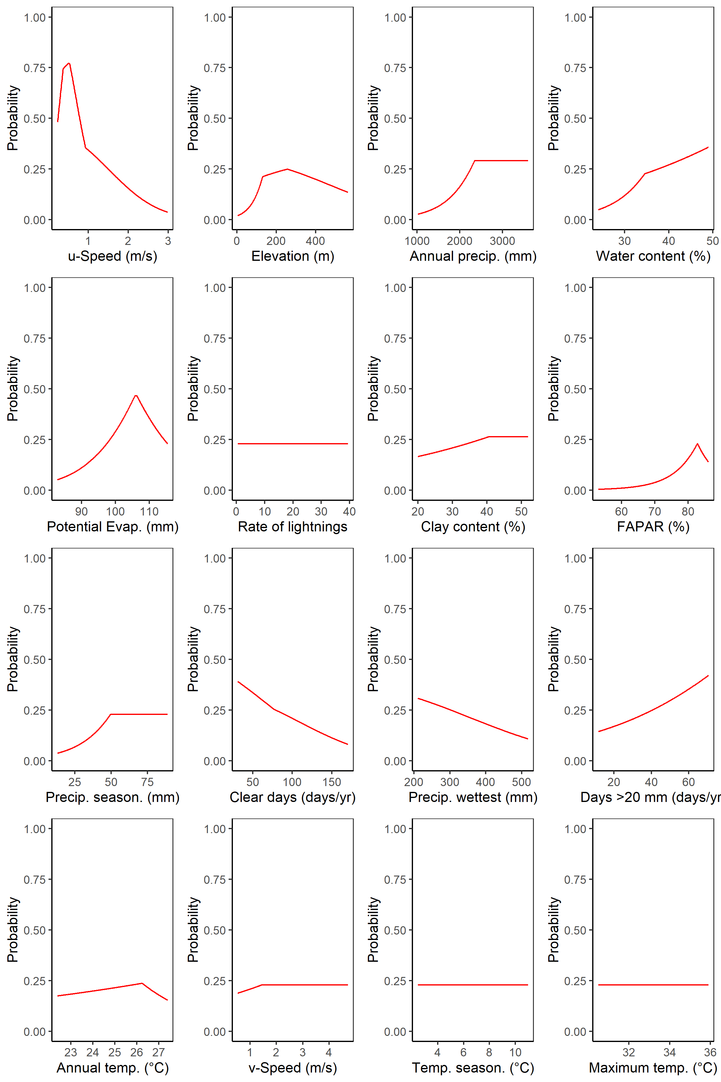

Figure 5. The marginal plot obtained for each environmental variable in the Maximum Entropy model, keeping others constant on the average. Lines close to horizontal indicate a given environmental factor having little effect on the probability of tall trees.

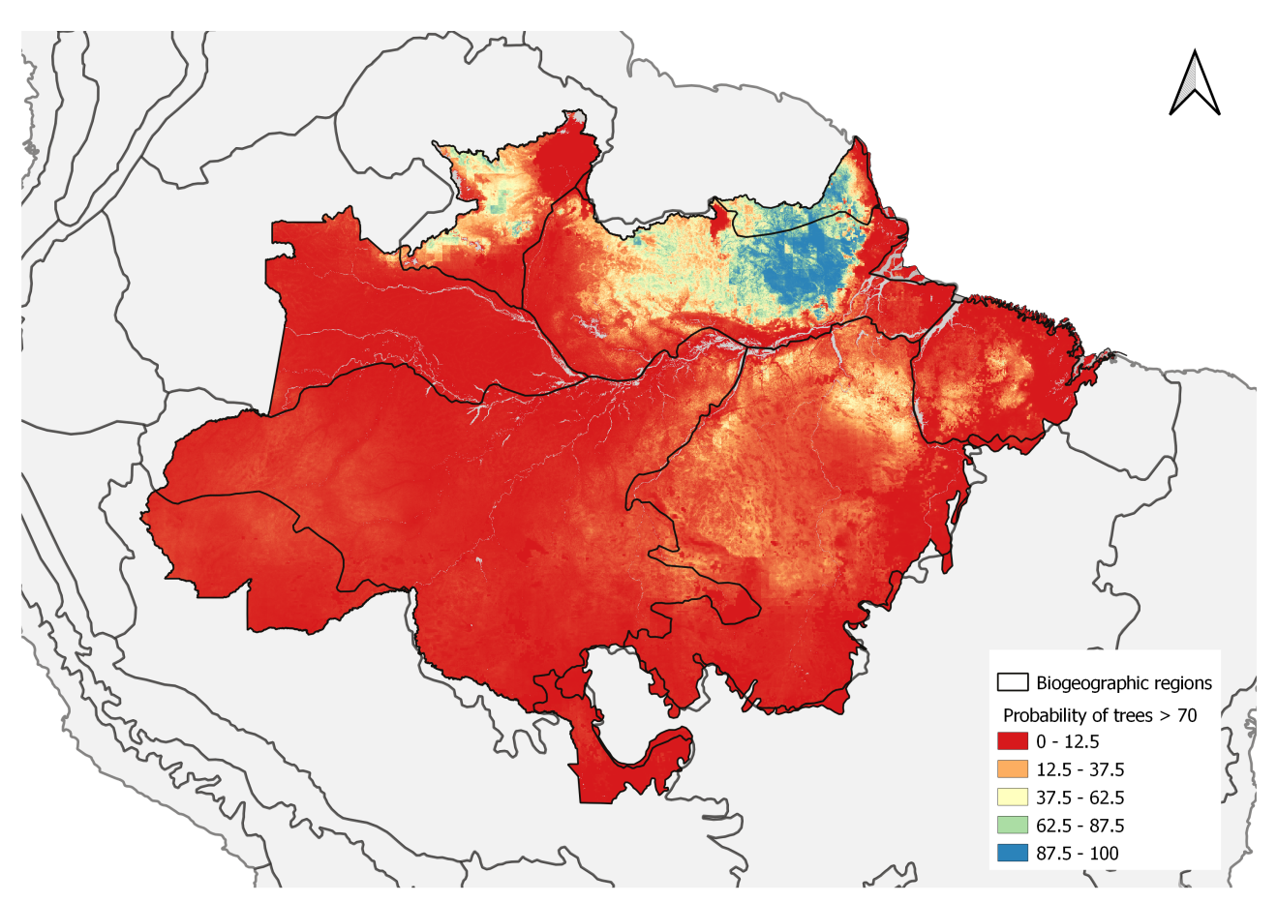

Figure 6. The probability of tall tree occurrence based on environmental conditions estimated by the Maximum Entropy model. Available at https://doi.org/10.5281/zenodo.4037101.

# Discussion

The drivers of height development are fundamentally different from those influencing the occurrence of giant trees. While changes in wind and elevation explain 74.6 % of the probability of giant trees occurrence, the maximum height distribution have a much more complex variable relationship. The number of cloud days stands out as the most relevant variable to explain maximum height distribution, but followed close by wind speed, soil clay content, elevation, precipitation and temperature seasonality, potential evapotranspiration, and maximum temperature.

## Maximum height distribution

The myriad of environmental variables with confounding effects on species composition, as well as on their physiological and structural traits, play a crucial role in the tree lifespan (Muller-Landau, 2004) and, consequently, in height development. Previous study showed that two main gradients occurs in Amazon: one from the Guiana Shield to the southwestern Amazon, congruent with variation in soil fertility, and another gradient from Colombia to the southeastern Amazon related to the length of the dry season (ter Steege et al., 2006). However, our results indicate that maximum height pattern reflect more than a simple geographical gradiente.

Maximum height was strong related to cloudy days, followed by soil clay content, elevation, annual precipitation and precipitation seasonality. An increase in cloud-free days goes together with an increase in direct solar radiation (Barkhordarian et al., 2019), which, along with changes in the Vapor Pressure Deficit, or atmospheric dryness, drive changes in the physiological function of trees (Williams et al., 2012; Nunes et al., 2019). The increase in diffuse radiation led by cloudy conditions induces an increase in photosynthetic activity (Gu, 2003). Tall trees have direct exposure to sunlight and high temperatures lead to higher stomatal control to avoid excessive water loss (Drake et al., 2018; Rowland et al., 2015). Tree responses to direct solar radiation are dependent on the species and developmental stage, with physiological and structural changes to maximize either growth or survival (Wright et al., 2004; Nunes et al., 2019; Poorter & Bongers, 2006). As trees grow taller, increasing leaf water stress due to gravity and path length resistance may limit leaf expansion and photosynthesis, and consequently height growth (Koch et al., 2004).

An increase in soil clay content also translated into an increase in maximum height. Clay content is usually highest on flat terrain (Laurance et al., 1999) decreasing from about 75% to 5% when moving from the plateau areas to the valleys (Ferraz et al., 1998; Toledo et al., 2016). A previous study showed an increase in wood density from stands on sandy soils in valleys to clayey soils on plateaus at a local scale in Central Amazon, and lower tree mortality rates in clayey soils (Toledo et al., 2016). These patterns were primarily driven by soil moisture - correlated to depth to water table - causing shifts in tree community composition (Schietti et al., 2013), and favoring higher hydraulic safety in the lower soil moisture areas of the plateaus (Toledo et al., 2016; Cosme et al., 2017). We suggest that the structured soils allow trees to obtain an additional volume of water during the dry season towards eastern Amazon, where soils tend to be richer in clay compared to central and western Amazon (Fisher et al., 2008; Hodnett et al., 1997). The dimorphic root systems associated with structured, clayey soils can redistribute water from deep layers to the soil surface during periods of drought (Broedel et al., 2017).

Elevation was also a key predictor of tree height, with low-lying forests growing potentially less than trees in terrains over 40 m a.s.l.. The topographic gradient is likely to be related to the likelihood of flooding in the low elevation transects on the lowlands. Rivers erode the *terra firme* terraces and create floodplains of variable sizes dating to the Miocene, with terrace–floodplain elevation differences decreasing eastwards from the Andes (Hamilton et al., 2007). The terrace and floodplain forests in the Amazon also have differences related to species turnover, which reveals the micro-topography effects on the survival rate in Amazonian forests (Asner et al., 2015).

Mean annual precipitation was also a key factor for trees to grow taller. A tolerance curve associated the height of tall trees with precipitation, peaking at  2,300 mm  yr-1 as optimal, but also showing that areas too dry or too wet may both inhibit the growth of tall trees. Thus, we observed a decline in maximum tree height in regions with annual precipitations below 1,500 mm yr-1 or above 3,000 mm yr-1. The availability of soil water depends on both precipitation and evapotranspiration, and our results suggest that below 1,500 mm yr-1 evapotranspiration may exceed precipitation in the Amazon (Scheffer et al., 2018), and mortality by the hydraulic failure may occur for trees near their maximum height (McDowell et al., 2008). Mean annual precipitation above 2,300 mm  year-1 may be related to exceeding water, and the combination of high precipitation and poorly drained soils may result in anaerobic conditions with negative effects on tree growth and survival (Quesada et al., 2009). Furthermore, higher precipitation tends to be related to the occurrence of storms and stronger winds with increases in tree mortality (Aleixo et al., 2019).

## Conditions supporting tall trees

In our study, the low wind speed was determined as the single most important predictor of the occurrence of the tallest trees in the Brazilian Amazon. The fact that trees adapt to their wind environment and are shorter in windy locations has been widely observed in temperate regions (Telewski, 2006, Bonnesoeur et al., 2016). We observed a similar effect across the Amazon, with trees over 70 m tall having a 50-75% likelihood of surviving in the calmest areas but a sharply decreasing probability with stronger winds. This agrees with previous findings that disturbance rates are three times higher in the Western Amazon (Espírito-Santo et al., 2014) and may demonstrate how significant the role of wind is in shaping the niche for extraordinarily tall trees. The importance of wind speed was also apparent in the Random Forest model which showed a 9 m reduction in the estimated tree height from the calmest to the windiest areas. The zonal velocity (i.e. the eastward component), which is the prevailing wind direction in the region, drives this pattern.

A balance between tree structural strength and wind shearing forces contributes to set an upper limit to tree height development (Klein et al., 2015). Trees adapt their growth rates to their local wind environment,  although the scale of this effect is unknown (Telewski, 2006; Bonnesoeur et al., 2016). Large-scale wind patterns in the Amazon are dominated by the easterly trade winds. Wind damage is most common from September to February (Negrón-Juárez et al., 2017) and taller trees have higher rates of mortality in wind storms (Rifai et al., 2016). Remote sensing analyses have shown that disturbance rates are much higher in the western Amazon compared to the east (Espírito-Santo et al., 2014).

Besides the ERA5 wind product does not show a magnitude technically associated to tree damage, its long-term mean speed could indicate variability and trends between regions, which seems to be relevant in our amazonian-scale analysis. To compute the wind speed map, ERA5 does not ingest surface winds from land stations. This is necessary to avoid areas with inhomogeneous terrain, where stations experience strong local influences and do represent the grid-area winds appropriately. As a result, ERA5 is parametrized in planetary boundary layers schemes from surface characteristics, stability indices and lowering the inland speed (Ramon et al., 2019).

Removing wind componentes from the maximum entropy model, the importance of zonal wind speed shifts to lightning (importance changes from 3 to 34), potential evapotranspiration (importance changes from 4 to 18) and precipitation seasonality (importance changes from 0.5 to 15). Secondary factors such elevation, annual precipitation and water content did not change after removing wind speed. This shifts indicates that wind speed is indeed adding information which is scattered in others factors, and related to anomalous events (i.e. lightning and seasonality).

The locations of the tall trees (> 70 m) in the eastern Amazon coincide with forests that have a high basal area predicted by statistical modeling of permanent plot data (Malhi et al., 2006; ter Steege et al., 2006). Young soils nearer the Andes, as well as the sedimented and flooded lowlands, are richer in nutrients, thereby supporting fast-growing, low wood density species with high turnover rates and, as a result, the trees do not reach extremely large sizes (Marra et al., 2014; Quesada et al., 2011; Phillips et al., 2004).

Floristic, structural, and demographic patterns reflect more than a simple east-west gradient associated to a complex history of deposition and erosion dating to the Miocene (Higgins et al., 2011). The Fabaceae family contains most of the large trees and grow successfully in low-dynamics environments such as the Guiana Shields. Higher occurrence of the Fabaceae in these low-fertility soils may occur due to the ability to fix nitrogen in the soil and ectomycorrhizal association (Webb & Sprent, 2002; Sprent, 2009).

Many physiological and structural traits are already related with a spatial patterns within the Amazon Basin (Baker et al., 2004; Fyllas et al., 2012; Patiño et al., 2012). Wood density is driven by shifts in tree species composition associated with infertile soils in eastern Amazon and the Guyanas (Terborgh & Andresen, 1998; Malhi et al., 2006). Soil physical properties combined with limited nutrient supply in eastern Amazon favor slow-growing species that invest their resources in structures that can support taller and bigger trees with a long lifespan (Malhi et al., 2004; Quesada et al., 2009).

Interestingly, our data showed that the lightning rate was only weakly related to maximum forest height patterns in both the Random Forests and MaxEnt models. Despite being relevant to the death of individual trees (Marra et al., 2014; Bonnesoeur et al., 2016; Niklas, 1998) and being the key factor causing tree deaths in tropical forests of Panama (Yanoviak et al., 2019), lightning and storms do not seem to impact the potential dominant tree of a region, nor to limit the survival of the tallest trees, in light of our results.

Plant size distributions can be understood as the demographic consequence of size‐dependent variation in growth and mortality in old-growth forests, and the mortality of large trees is independent of resource availability and competition (Coomes et al., 2003). Understanding the spatial distribution of maximum tree height in tropical forests and how it is associated with environmental conditions and tree functional traits is of fundamental importance. Emergent trees that reach their maximum height are responsible for a significant amount of the transpired water flux and the above-ground carbon storage. Trees which reach these extraordinary heights are rare and only a small proportion of species have the necessary adaptions to achieve this. However, these adaptations are not sufficient alone, and maximum tree height is strongly influenced by environmental conditions.

Current climate models differ in their predictions of large-scale changes in wind patterns, although warmer temperatures will mean that the air can hold more moisture, which will likely make convective storms more intense. Whatever the change in environmental conditions, it is likely to occur faster than trees can adapt. Our results showed that precipitation and temperature have a lower importance than expected from previous studies. Nevertheless, changes in the precipitation and radiation regimes (strongly linked to the number of cloudy days) could reshape our forest biomes. Ultimately, the association between environmental conditions and mechanisms of natural selection, where some traits have some advantages in comparison to others influencing the survival of the most adaptable, are key to understanding the complexity of this process in a changing climate.

# Acknowledgements

Funding was provided by the Coordenação de Aperfeiçoamento de Pessoal de Nível Superior Brasil (CAPES; Finance Code 001); Conselho Nacional de Desenvolvi­mento Científico e Tecnológico (Processes 403297/2016-8 and 301661/2019-7); Amazon Fund (grant 14.2.0929.1); National Academy of Sciences and US Agency for International Development (grant AID-OAA-A-11-00012); Universidade Federal dos Vales do Jequitinhonha e Mucuri (UFVJM); Instituto Nacional de Pesquisas Espaciais (INPE);

D. Almeida was supported by the São Paulo Research Foundation (#2018/21338-3 and #2019/14697-0);

B. Gimenez, G. Spanner and N. Higuchi were supported by INCT-Madeiras da Amazônia and Next Generation Ecosystem Experiments-Tropics (NGEE-Tropics), as part of DOE’s Terrestrial Ecosystem Science Program – Contract No. DE-AC02-05CH11231;

T. Jackson and D. Coomes were supported by the UK Natural Environment Research Council grant NE/S010750/1;

M. Nunes was supported by the Academy of Finland (decision number 319905);

J. Rosette was supported by the Royal Society University Research Fellowship (URF\R\191014);

# References

Abatzoglou, J. T., Dobrowski, S. Z., Parks, S. A., & Hegewisch, K. C. (2018). TerraClimate a high-resolution global dataset of monthly climate and climatic water balance from 1958{\textendash}2015. Scientific Data, 5(1). https://doi.org/10.1038/sdata.2017.191

Albergel, C., Dutra, E., Bonan, B., Zheng, Y., Munier, S., Balsamo, G., … Calvet, J.-C. (2019). Monitoring and Forecasting the Impact of the 2018 Summer Heatwave on Vegetation. Remote Sensing, 11(5), 520. https://doi.org/10.3390/rs11050520

Albrecht, R. I., Goodman, S. J., Buechler, D. E., Blakeslee, R. J., & Christian, H. J. (2016). Where Are the Lightning Hotspots on Earth? Bulletin of the American Meteorological Society, 97(11), 2051–2068. https://doi.org/10.1175/bams-d-14-00193.1

Aleixo, I., Norris, D., Hemerik, L., Barbosa, A., Prata, E., Costa, F., & Poorter, L. (2019). Amazonian rainforest tree mortality driven by climate and functional traits. Nature Climate Change, 9(5), 384–388. https://doi.org/10.1038/s41558-019-0458-0

Almeida, D. R. A., Stark, S. C., Schietti, J., Camargo, J. L. C., Amazonas, N. T., Gorgens, E. B., … Brancalion, P. H. S. (2019). Persistent effects of fragmentation on tropical rainforest canopy structure after 20~yr of isolation. Ecological Applications, 29(6). https://doi.org/10.1002/eap.1952

Anderegg, W. R. L., Klein, T., Bartlett, M., Sack, L., Pellegrini, A. F. A., Choat, B., & Jansen, S. (2016). Meta-analysis reveals that hydraulic traits explain cross-species patterns of drought-induced tree mortality across the globe. Proceedings of the National Academy of Sciences, 113(18), 5024–5029. https://doi.org/10.1073/pnas.1525678113

Arsanjani, J. J., Vaz, E., Bakillah, M., & Mooney, P. (2014). Towards initiating OpenLandMap founded on citizens’ science: The current status of land use features of OpenStreetMap in Europe.

Asner, G. P., Powell, G. V. N., Mascaro, J., Knapp, D. E., Clark, J. K., Jacobson, J., … Hughes, R. F. (2010). High-resolution forest carbon stocks and emissions in the Amazon. Proceedings of the National Academy of Sciences, 107(38), 16738–16742. https://doi.org/10.1073/pnas.1004875107

Asner, G. P. (2009). Tropical forest carbon assessment: integrating satellite and airborne mapping approaches. Environmental Research Letters, 4(3), 34009. https://doi.org/10.1088/1748-9326/4/3/034009

Asner, G. P., Anderson, C. B., Martin, R. E., Tupayachi, R., Knapp, D. E., & Sinca, F. (2015). Landscape biogeochemistry reflected in shifting distributions of chemical traits in the Amazon forest canopy. Nature Geoscience, 8(7), 567–573.

Bae, S., Levick, S. R., Heidrich, L., Magdon, P., Leutner, B. F., Wöllauer, S., … Müller, J. (2019). Radar vision in the mapping of forest biodiversity from space. Nature Communications, 10(1). https://doi.org/10.1038/s41467-019-12737-x

Baker, T. R., Phillips, O. L., Malhi, Y., Almeida, S., Arroyo, L., Fiore, A. Di, … Martinez, R. V. (2004). Variation in wood density determines spatial patterns {inAmazonian} forest biomass. Global Change Biology, 10(5), 545–562. https://doi.org/10.1111/j.1365-2486.2004.00751.x

Barkhordarian, A., Saatchi, S. S., Behrangi, A., Loikith, P. C., & Mechoso, C. R. (2019). A Recent Systematic Increase in Vapor Pressure Deficit over Tropical South America. Scientific Reports, 9(1). https://doi.org/10.1038/s41598-019-51857-8

Bennett, A. C., McDowell, N. G., Allen, C. D., & Anderson-Teixeira, K. J. (2015). Larger trees suffer most during drought in forests worldwide. Nature Plants, 1(10). https://doi.org/10.1038/nplants.2015.139

Bisht, G., & Bras, R. L. (2010). Estimation of net radiation from the {MODIS} data under all sky conditions: Southern Great Plains case study. Remote Sensing of Environment, 114(7), 1522–1534. https://doi.org/10.1016/j.rse.2010.02.007

Bonnesoeur, V., Constant, T., Moulia, B., & Fournier, M. (2016). Forest trees filter chronic wind-signals to acclimate to high winds. New Phytologist, 210(3), 850–860. https://doi.org/10.1111/nph.13836

Broedel, E., Tomasella, J., Cândido, L. A., & von Randow, C. (2017). Deep soil water dynamics in an undisturbed primary forest in central Amazonia: Differences between normal years and the 2005 drought. Hydrological Processes, 31(9), 1749–1759. https://doi.org/10.1002/hyp.11143

Cao, M., & Woodward, F. I. (1998). Net primary and ecosystem production and carbon stocks of terrestrial ecosystems and their responses to climate change. Global Change Biology, 4(2), 185–198. https://doi.org/10.1046/j.1365-2486.1998.00125.x

Chave, J., Piponiot, C., Maréchaux, I., de, F. H., Larpin, D., Fischer, F. J., … Hérault, B. (2020). Slow rate of secondary forest carbon accumulation in the Guianas compared with the rest of the Neotropics. Ecol Appl, 30, e02004.

Coomes, D. A., Dalponte, M., Jucker, T., Asner, G. P., Banin, L. F., Burslem, D. F. R. P., … Qie, L. (2017). Area-based vs tree-centric approaches to mapping forest carbon in Southeast Asian forests from airborne laser scanning data. Remote Sensing of Environment, 194, 77–88. https://doi.org/10.1016/j.rse.2017.03.017

Coomes, D. A., Duncan, R. P., Allen, R. B., & Truscott, J. (2003). Disturbances prevent stem size-density distributions in natural forests from following scaling relationships. Ecology Letters, 6(11), 980–989. https://doi.org/10.1046/j.1461-0248.2003.00520.x

Coomes, D. A., Jenkins, K. L., & Cole, L. E. S. (2006). Scaling of tree vascular transport systems along gradients of nutrient supply and altitude. Biology Letters, 3(1), 87–90. https://doi.org/10.1098/rsbl.2006.0551

Cosme, L. H. M., Schietti, J., Costa, F. R. C., & Oliveira, R. S. (2017). The importance of hydraulic architecture to the distribution patterns of trees in a central Amazonian forest. New Phytologist, 215(1), 113–125. https://doi.org/10.1111/nph.14508

Dalponte, M., & Coomes, D. A. (2016). Tree-centric mapping of forest carbon density from airborne laser scanning and hyperspectral data. Methods in Ecology and Evolution, 7(10), 1236–1245. https://doi.org/10.1111/2041-210x.12575

Díaz, S., Kattge, J., Cornelissen, J. H. C., Wright, I. J., Lavorel, S., Dray, S., … others. (2016). The global spectrum of plant form and function. Nature, 529(7585), 167–171.

Drake, J. E., Tjoelker, M. G., Vårhammar, A., Medlyn, B., Reich, P. B., Leigh, A., … Barton, C. V. M. (2018). Trees tolerate an extreme heatwave via sustained transpirational cooling and increased leaf thermal tolerance. Global Change Biology, 24(6), 2390–2402. https://doi.org/10.1111/gcb.14037

Enquist, B. J., Abraham, A. J., Harfoot, M. B. J., Malhi, Y., & Doughty, C. E. (2020). The megabiota are disproportionately important for biosphere functioning. Nature Communications, 11(1). https://doi.org/10.1038/s41467-020-14369-y

Espírito-Santo, F. D. B., Gloor, M., Keller, M., Malhi, Y., Saatchi, S., Nelson, B., … others. (2014). Size and frequency of natural forest disturbances and the Amazon forest carbon balance. Nature Communications, 5(1), 1–6.

Farr, T. G., Rosen, P. A., Caro, E., Crippen, R., Duren, R., Hensley, S., … others. (2007). The shuttle radar topography mission. Reviews of Geophysics, 45(2).

Feldpausch, T. R., Lloyd, J., Lewis, S. L., Brienen, R. J. W., Gloor, M., Monteagudo Mendoza, A., … others. (2012). Tree height integrated into pantropical forest biomass estimates. Biogeosciences, 3381–3403.

Ferraz, J., Ohta, S., & Sales, P. C. de. (1998). Distribuição dos solos ao longo de dois transectos em floresta primária ao norte de Manaus (AM). Higuchi, N., Campos, MAA, Sampaio, PTB, and Dos Santos, J., Espaço Comunicaçao Ltda., Manaus, Brazil, 264.

Fick, S. E., & Hijmans, R. J. (2017). {WorldClim} 2: new 1-km spatial resolution climate surfaces for global land areas. International Journal of Climatology, 37(12), 4302–4315. https://doi.org/10.1002/joc.5086

Fisher, R. A., Williams, M., de Lourdes Ruivo, M., de Costa, A. L., & Meir, P. (2008). Evaluating climatic and soil water controls on evapotranspiration at two Amazonian rainforest sites. Agricultural and Forest Meteorology, 148(6–7), 850–861. https://doi.org/10.1016/j.agrformet.2007.12.001

Funk, C., Peterson, P., Landsfeld, M., Pedreros, D., Verdin, J., Shukla, S., … Michaelsen, J. (2015). The climate hazards infrared precipitation with stations{\textemdash}a new environmental record for monitoring extremes. Scientific Data, 2(1). https://doi.org/10.1038/sdata.2015.66

Fyllas, N. M., Patiño, S., Baker, T. R., Nardoto, G. B., Martinelli, L. A., Quesada, C. A., … Lloyd, J. (2009). Basin-wide variations in foliar properties of Amazonian forest: phylogeny soils and climate. Biogeosciences, 6(11), 2677–2708. https://doi.org/10.5194/bg-6-2677-2009

Fyllas, N. M., Quesada, C. A., & Lloyd, J. (2012). Deriving Plant Functional Types for Amazonian forests for use in vegetation dynamics models. Perspectives in Plant Ecology Evolution and Systematics, 14(2), 97–110. https://doi.org/10.1016/j.ppees.2011.11.001

Görgens, E. B., Soares, C. P. B., Nunes, M. H., & Rodriguez, L. C. E. (2016). Characterization of Brazilian forest types utilizing canopy height profiles derived from airborne laser scanning. Applied Vegetation Science, 19(3), 518–527. https://doi.org/10.1111/avsc.12224

Gorgens, E. B., Motta, A. Z., Assis, M., Nunes, M. H., Jackson, T., Coomes, D., … Ometto, J. P. (2019). The giant trees of the Amazon basin. Frontiers in Ecology and the Environment, 17(7), 373–374. https://doi.org/10.1002/fee.2085

Gu, L. (2003). Response of a Deciduous Forest to the Mount Pinatubo Eruption: Enhanced Photosynthesis. Science, 299(5615), 2035–2038. https://doi.org/10.1126/science.1078366

Hacke, U. G., Sperry, J. S., Pockman, W. T., Davis, S. D., & McCulloh, K. A. (2001). Trends in wood density and structure are linked to prevention of xylem implosion by negative pressure. Oecologia, 126(4), 457–461. https://doi.org/10.1007/s004420100628

Hamilton, S. K., Kellndorfer, J., Lehner, B., & Tobler, M. (2007). Remote sensing of floodplain geomorphology as a surrogate for biodiversity in a tropical river system (Madre de Dios Peru). Geomorphology, 89(1–2), 23–38. https://doi.org/10.1016/j.geomorph.2006.07.024

Higgins, M. A., Ruokolainen, K., Tuomisto, H., Llerena, N., Cardenas, G., Phillips, O. L., … Räsänen, M. (2011). Geological control of floristic composition in Amazonian forests. Journal of Biogeography, 38(11), 2136–2149. https://doi.org/10.1111/j.1365-2699.2011.02585.x

Hijmans, R. J., Cameron, S. E., Parra, J. L., Jones, P. G., & Jarvis, A. (2005). Very high resolution interpolated climate surfaces for global land areas. International Journal of Climatology, 25(15), 1965–1978. https://doi.org/10.1002/joc.1276

Hodnett, M. G., Vendrame, I., Marques Filho, A. D. O., Oyama, M. D., & Tomasella, J. (1997). Soil water storage and groundwater behaviour in a catenary sequence beneath forest in central Amazonia: I. Comparisons between plateau, slope and valley floor. Hydrology and Earth System Sciences Discussions, 1.

~~Huete, A. R., Didan, K., Shimabukuro, Y. E., Ratana, P., Saleska, S. R., Hutyra, L. R., … Myneni, R. (2006). Amazon rainforests green-up with sunlight in dry season. Geophysical Research Letters, 33(6). https://doi.org/10.1029/2005gl025583~~

Jagels, R., Equiza, M. A., Maguire, D. A., & Cirelli, D. (2018). Do tall tree species have higher relative stiffness than shorter species? American Journal of Botany, 105(10), 1617–1630. https://doi.org/10.1002/ajb2.1171

Kang, S., Running, S. W., Zhao, M., Kimball, J. S., & Glassy, J. (2005). Improving continuity of {MODIS} terrestrial photosynthesis products using an interpolation scheme for cloudy pixels. International Journal of Remote Sensing, 26(8), 1659–1676. https://doi.org/10.1080/01431160512331326693

Klein, T., Randin, C., & Körner, C. (2015). Water availability predicts forest canopy height at the global~scale. Ecology Letters, 18(12), 1311–1320. https://doi.org/10.1111/ele.12525

Koch, G. W., Sillett, S. C., Jennings, G. M., & Davis, S. D. (2004). The limits to tree height. Nature, 428(6985), 851–854. https://doi.org/10.1038/nature02417

Larjavaara, M. (2013). The world{\textquotesingle}s tallest trees grow in thermally similar climates. New Phytologist, 202(2), 344–349. https://doi.org/10.1111/nph.12656

Laurance, W. F., Fearnside, P. M., Laurance, S. G., Delamonica, P., Lovejoy, T. E., Merona, J. M. R., … Gascon, C. (1999). Relationship between soils and Amazon forest biomass: a landscape-scale study. Forest Ecology and Management, 118(1–3), 127–138. https://doi.org/10.1016/s0378-1127(98)00494-0

Lindenmayer, D. B., & Laurance, W. F. (2016). The Unique Challenges of Conserving Large Old Trees. Trends in Ecology & Evolution, 31(6), 416–418. https://doi.org/10.1016/j.tree.2016.03.003

Liu, J., Liu, D., & Alsdorf, D. (2014). Extracting Ground-Level {DEM} From {SRTM} {DEM} in Forest Environments Based on Mathematical Morphology. {IEEE} Transactions on Geoscience and Remote Sensing, 52(10), 6333–6340. https://doi.org/10.1109/tgrs.2013.2296232

Malhi, Y., Baker, T. R., Phillips, O. L., Almeida, S., Alvarez, E., Arroyo, L., … Lloyd, J. (2004). The above-ground coarse wood productivity of 104 Neotropical forest plots. Global Change Biology, 10(5), 563–591. https://doi.org/10.1111/j.1529-8817.2003.00778.x

Malhi, Y., Wood, D., Baker, T. R., Wright, J., Phillips, O. L., Cochrane, T., … others. (2006). The regional variation of aboveground live biomass in old-growth Amazonian forests. Global Change Biology, 12(7), 1107–1138. https://doi.org/10.1111/j.1365-2486.2006.01120.x

Marra, D. M., Chambers, J. Q., Higuchi, N., Trumbore, S. E., Ribeiro, G. H. P. M., dos Santos, J., … Wirth, C. (2014). Large-Scale Wind Disturbances Promote Tree Diversity in a Central Amazon Forest. {PLoS} {ONE}, 9(8), e103711. https://doi.org/10.1371/journal.pone.0103711

Marvin, D. C., Asner, G. P., Knapp, D. E., Anderson, C. B., Martin, R. E., Sinca, F., & Tupayachi, R. (2014). Amazonian landscapes and the bias in field studies of forest structure and biomass. Proc Natl Acad Sci U S A, 111, E5224-32.

Mason, P. J., Zillman, J. W., Simmons, A., Lindstrom, E. J., Harrison, D. E., Dolman, H., … others. (2010). Implementation plan for the global observing system for climate in support of the UNFCCC (2010 Update).

McDowell, N., Allen, C. D., Anderson-Teixeira, K., Brando, P., Brienen, R., Chambers, J., … others. (2018). Drivers and mechanisms of tree mortality in moist tropical forests. New Phytologist, 219(3), 851–869.

McDowell, N., Pockman, W. T., Allen, C. D., Breshears, D. D., Cobb, N., Kolb, T., … Yepez, E. A. (2008). Mechanisms of plant survival and mortality during drought: why do some plants survive while others succumb to drought? New Phytologist, 178(4), 719–739. https://doi.org/10.1111/j.1469-8137.2008.02436.x

McDowell, N. G., & Allen, C. D. (2015). Darcy{\textquotesingle}s law predicts widespread forest mortality under climate warming. Nature Climate Change, 5(7), 669–672. https://doi.org/10.1038/nclimate2641

Moles, A. T., Warton, D. I., Warman, L., Swenson, N. G., Laffan, S. W., Zanne, A. E., … Leishman, M. R. (2009). Global patterns in plant height. Journal of Ecology, 97(5), 923–932.

Morrone, J. J. (2014). Biogeographical regionalisation of the Neotropical region. Zootaxa, 3782(1), 1. https://doi.org/10.11646/zootaxa.3782.1.1

~~Morton, D. C., Nagol, J., Carabajal, C. C., Rosette, J., Palace, M., Cook, B. D., … North, P. R. J. (2014). Amazon forests maintain consistent canopy structure and greenness during the dry season. Nature, 506(7487), 221–224. https://doi.org/10.1038/nature13006~~

Muller-Landau, H. C. (2004). Interspecific and Inter-site Variation in Wood Specific Gravity of Tropical Trees. Biotropica, 36(1), 20–32. https://doi.org/10.1111/j.1744-7429.2004.tb00292.x

Negrón-Juárez, R., Jenkins, H., Raupp, C., Riley, W., Kueppers, L., Marra, D. M., … Higuchi, N. (2017). Windthrow Variability in Central Amazonia. Atmosphere, 8(12), 28. https://doi.org/10.3390/atmos8020028

Niklas, K. J. (2007). Maximum plant height and the biophysical factors that limit it. Tree Physiology, 27(3), 433–440. https://doi.org/10.1093/treephys/27.3.433

Niklas, K. J. (1998). The influence of gravity and wind on land plant evolution. Review of Palaeobotany and Palynology, 102(1–2), 1–14. https://doi.org/10.1016/s0034-6667(98)00011-6

Nunes, M. H., Both, S., Bongalov, B., Brelsford, C., Khoury, S., Burslem, D. F. R. P., … Cutler, M. E. J. (2019). Changes in leaf functional traits of rainforest canopy trees associated with an El Niño event in Borneo. Environmental Research Letters, 14(8), 85005. https://doi.org/10.1088/1748-9326/ab2eae

Olauson, J. (2018). {ERA}5: The new champion of wind power modelling? Renewable Energy, 126, 322–331. https://doi.org/10.1016/j.renene.2018.03.056

Patiño, S., Fyllas, N. M., Baker, T. R., Paiva, R., Quesada, C. A., Santos, A. J. B., … Lloyd, J. (2012). Coordination of physiological and structural traits in Amazon forest trees. Biogeosciences, 9(2), 775–801. https://doi.org/10.5194/bg-9-775-2012

Pennisi, E. (2019). Forest giants are the trees most at risk. Science, 365(6457), 962–963. https://doi.org/10.1126/science.365.6457.962

Phillips, O. L., Baker, T. R., Arroyo, L., Higuchi, N., Killeen, T. J., Laurance, W. F., … others. (2004). Pattern and process in Amazon tree turnover, 1976--2001. Philosophical Transactions of the Royal Society of London. Series B: Biological Sciences, 359(1443), 381–407.

Phillips, S. J., Anderson, R. P., Schapire, R. E. (2006). Maximum entropy modeling of species geographic distributions. Ecological Modelling 190, 231–259.

Poorter, L., & Bongers, F. (2006). Leaf traits are good predictors of plant performance across 53 rain forest species. Ecology, 87(7), 1733–1743.

Powers, J. S., Vargas-G, G., Brodribb, T. J., Schwartz, N. B., Perez-Aviles, D., Smith-Martin, C. M., … Medvigy, D. (2020). A catastrophic tropical drought kills hydraulically vulnerable tree species. Global Change Biology. https://doi.org/10.1111/gcb.15037

Quesada, C. A., Lloyd, J., Anderson, L. O., Fyllas, N. M., Schwarz, M., & Czimczik, C. I. (2011). Soils of Amazonia with particular reference to the {RAINFOR} sites. Biogeosciences, 8(6), 1415–1440. https://doi.org/10.5194/bg-8-1415-2011

Quesada, C. A., Lloyd, J., Schwarz, M., Baker, T. R., Phillips, O. L., Patiño, S., … others. (2009). Regional and large-scale patterns in Amazon forest structure and function are mediated by variations in soil physical and chemical properties. Biogeosciences Discussion, 6, 3993–4057.

Quesada, C. A., Phillips, O. L., Schwarz, M., Czimczik, C. I., Baker, T. R., Patiño, S., … Lloyd, J. (2012). Basin-wide variations in Amazon forest structure and function are mediated by both soils and climate. Biogeosciences, 9(6), 2203–2246. https://doi.org/10.5194/bg-9-2203-2012

Ramon, J., Lledó, L., Torralba, V., Soret, A., & Doblas-Reyes, F. J. (2019). What global reanalysis best represents near-surface winds? Quarterly Journal of the Royal Meteorological Society, 145(724), 3236–3251. https://doi.org/10.1002/qj.3616

Rifai, S. W., Urquiza Muñoz, J. D., Negrón-Juárez, R. I., Ram\’\irez Arévalo, F. R., Tello-Espinoza, R., Vanderwel, M. C., … Bohlman, S. A. (2016). Landscape-scale consequences of differential tree mortality from catastrophic wind disturbance in the Amazon. Ecological Applications, 26(7), 2225–2237.

Rowland, L., da Costa, A. C. L., Galbraith, D. R., Oliveira, R. S., Binks, O. J., Oliveira, A. A. R., … Meir, P. (2015). Death from drought in tropical forests is triggered by hydraulics not carbon starvation. Nature, 528(7580), 119–122. https://doi.org/10.1038/nature15539

Rueda, M., Godoy, O., & Hawkins, B. A. (2016). Spatial and evolutionary parallelism between shade and drought tolerance explains the distributions of conifers in the conterminous United States. Global Ecology and Biogeography, 26(1), 31–42. https://doi.org/10.1111/geb.12511

Sakschewski, B., von Bloh, W., Boit, A., Poorter, L., Peña-Claros, M., Heinke, J., … Thonicke, K. (2016). Resilience of Amazon forests emerges from plant trait~diversity. Nature Climate Change, 6(11), 1032–1036. https://doi.org/10.1038/nclimate3109

Scheffer, M., Xu, C., Hantson, S., Holmgren, M., Los, S. O., & van, N. E. H. (2018). A global climate niche for giant trees. Glob Chang Biol, 24, 2875–2883.

Scheffer, M., Xu, C., Hantson, S., Holmgren, M., Los, S. O., & van Nes, E. H. (2018). A global climate niche for giant trees. Global Change Biology, 24(7), 2875–2883. https://doi.org/10.1111/gcb.14167

Schietti, J., Emilio, T., Rennó, C. D., Drucker, D. P., Costa, F. R. C., Nogueira, A., … Magnusson, W. E. (2013). Vertical distance from drainage drives floristic composition changes in an Amazonian rainforest. Plant Ecology & Diversity, 7(1–2), 241–253. https://doi.org/10.1080/17550874.2013.783642

Schimel, D., Pavlick, R., Fisher, J. B., Asner, G. P., Saatchi, S., Townsend, P., … Cox, P. (2015). Observing terrestrial ecosystems and the carbon cycle from space. Global Change Biology, 21(5), 1762–1776. https://doi.org/10.1111/gcb.12822

Simard, M., Fatoyinbo, L., Smetanka, C., Rivera-Monroy, V. H., Castañeda-Moya, E., Thomas, N., & der Stocken, T. Van. (2018). Mangrove canopy height globally related to precipitation temperature and cyclone frequency. Nature Geoscience, 12(1), 40–45. https://doi.org/10.1038/s41561-018-0279-1

Sprent, J. I. (2009). Legume Nodulation. Wiley-Blackwell. https://doi.org/10.1002/9781444316384

Stovall, A. E. L., Shugart, H., & Yang, X. (2019). Tree height explains mortality risk during an intense drought. Nature Communications, 10(1). https://doi.org/10.1038/s41467-019-12380-6

Stropp, J., Umbelino, B., Correia, R. A., Campos-Silva, J. V, Ladle, R. J., & Malhado, A. C. M. (2020). The ghosts of forests past and future: deforestation and botanical sampling in the Brazilian Amazon. Ecography. https://doi.org/10.1111/ecog.05026

Tao, X., Liang, S., He, T., & Jin, H. (2016). Estimation of fraction of absorbed photosynthetically active radiation from multiple satellite data: Model development and validation. Remote Sensing of Environment, 184, 539–557. https://doi.org/10.1016/j.rse.2016.07.036

Tejada, G., Görgens, E. B., Esp\’\irito-Santo, F. D. B., Cantinho, R. Z., & Ometto, J. P. (2019). Evaluating spatial coverage of data on the aboveground biomass in undisturbed forests in the Brazilian Amazon. Carbon Balance and Management, 14(1). https://doi.org/10.1186/s13021-019-0126-8

Telewski, F. W. (2006). A unified hypothesis of mechanoperception in plants. American Journal of Botany, 93(10), 1466–1476. https://doi.org/10.3732/ajb.93.10.1466

ter Steege, H., Pitman, N. C. A., Phillips, O. L., Chave, J., Sabatier, D., Duque, A., … Vásquez, R. (2006). Continental-scale patterns of canopy tree composition and function across Amazonia. Nature, 443(7110), 444–447. https://doi.org/10.1038/nature05134

Terborgh, J., & Andresen, E. (1998). The composition of Amazonian forests: patterns at local and regional scales. Journal of Tropical Ecology, 14(5), 645–664. https://doi.org/10.1017/s0266467498000455

Toledo, J. J., Castilho, C. V, Magnusson, W. E., & Nascimento, H. E. M. (2016). Soil controls biomass and dynamics of an Amazonian forest through the shifting of species and traits. Brazilian Journal of Botany, 40(2), 451–461. https://doi.org/10.1007/s40415-016-0351-2

Tuomisto, H., doninck, J. Van, Ruokolainen, K., Moulatlet, G. M., Figueiredo, F. O. G., Sirén, A., … Zuquim, G. (2019). Discovering floristic and geoecological gradients across Amazonia. Journal of Biogeography, 46(8), 1734–1748. https://doi.org/10.1111/jbi.13627

van Gelder, H. A., Poorter, L., & Sterck, F. J. (2006). Wood mechanics allometry, and life-history variation in a tropical rain forest tree community. New Phytologist, 171(2), 367–378. https://doi.org/10.1111/j.1469-8137.2006.01757.x

Webb, J. R., & Sprent, J. I. (2002). Nodulation in Legumes. Kew Bulletin, 57(3), 634. https://doi.org/10.2307/4110991

Williams, A. P., Allen, C. D., Macalady, A. K., Griffin, D., Woodhouse, C. A., Meko, D. M., … McDowell, N. G. (2012). Temperature as a potent driver of regional forest drought stress and tree mortality. Nature Climate Change, 3(3), 292–297. https://doi.org/10.1038/nclimate1693

Wright, I. J., Reich, P. B., Westoby, M., Ackerly, D. D., Baruch, Z., Bongers, F., … Villar, R. (2004). The worldwide leaf economics spectrum. Nature, 428, 821–827.

Yang, Y., Saatchi, S., Xu, L., Yu, Y., Lefsky, M., White, L., … Myneni, R. (2016). Abiotic Controls on Macroscale Variations of Humid Tropical Forest Height. Remote Sensing, 8(6), 494. https://doi.org/10.3390/rs8060494

Yanoviak, S. P., Gora, E. M., Bitzer, P. M., Burchfield, J. C., Muller-Landau, H. C., Detto, M., … Hubbell, S. P. (2019). Lightning is a major cause of large tree mortality in a lowland neotropical forest. New Phytologist, 225(5), 1936–1944. https://doi.org/10.1111/nph.16260